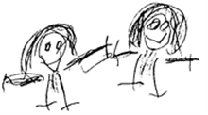
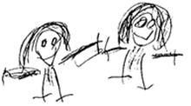

BRAMBLES CHILDCARE CIO

POLICY TITLE: | STUDENT PLACEMENT

POLICY REFERENCE: | BRAM30
Issue Number: | 03

2020-2021 | NAME | TITLE
Brambles Manager
Committee Member

2021-2022 | NAME | TITLE
Brambles Manager
Committee Member

2022-2023 | NAME | TITLE
Brambles Manager
Committee Member

Policy to be reviewed and signed annually (see above). Policy to be re-issued 3 yearly or when changes are required. Whichever occurs first.
Issue Date: | OCT 2020
Review Date: | OCT 2023

Statement of intent
Brambles Childcare CIO recognises that qualifications and training make an important contribution to the quality of the care and education provided by early years settings. As part of our commitment to quality, we offer a variety of student placements.

Aim
We aim to provide for students on placement with us experiences that contribute to the successful completion of their studies and that provide examples of quality practice in early years care and education.

Methods
- We require students to meet the 'suitable person' requirements of Ofsted.
- We require schools placing students under the age of 17 years with the setting to vouch for their good character.
- Students do not work unsupervised.
- Students who are placed in our setting on a short term basis are not counted in our staffing ratios.
- We take out employers' liability insurance and public liability insurance, which covers both trainees and voluntary helpers.
- We require students to keep to our confidentiality policy.
- We co-operate with students' tutors in order to help students to fulfil the requirements of their course of study.
- We provide students, at the first session of their placement, with a short induction on how our setting is managed, how our sessions are organised and our policies and procedures.
- We communicate a positive message to students about the value of qualifications and training.
- We make the needs of the children paramount by not admitting students in numbers that hinder the essential work of Brambles.

version History
Issue No | Significant changes from previous version | Author | Date
03 | Adopted on to new template | R Russell | 05/10/2020

