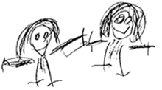
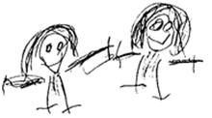

BRAMBLES CHILDCARE CIO

POLICY TITLE: | ADULT CODE OF CONDUCT

POLICY REFERENCE: | BRAM02
Issue Number: | 02

2020-2021 | NAME | TITLE
Brambles Manager
Committee Member

2021-2022 | NAME | TITLE
Brambles Manager
Committee Member

2022-2023 | NAME | TITLE
Brambles Manager
Committee Member

Policy to be reviewed and signed annually (see above). Policy to be re-issued 3 yearly or when changes are required. Whichever occurs first.
Issue Date: | OCT 2020
Review Date: | OCT 2023

We are aware of our position as role models for children and the need to lead by example. We seek to provide a harmonious workplace where children, parents/carers and staff feel safe, valued and protected. In order to achieve this we have a code of conduct for staff, parents/carers and visitors to be guided by:

- We require all staff, volunteers and students to provide a positive model of behaviour by treating children, parents/carers and one another with friendliness, care and courtesy.

- We familiarise new staff and volunteers with the Brambles Childcare Behaviour management policy.

- We do not shout or raise our voices unless we believe the safety of the child/staff member is compromised.

- No inappropriate language or phrases will be used.

- Confidentiality policy will be adhered to all times.

- We will endeavour to use a reassuring non-threatening tone and positive body language at all times. We are aware that aggressive body language or shouting presents a negative example of how we should behave as adults.

Any person presenting in an aggressive manner will be asked to leave, should anyone feel threatened we reserve the right to contact the police for assistance

version History
Issue No | Significant changes from previous version | Author | Date
02 | Adopted on to new template | R Russell | 05/10/2020

