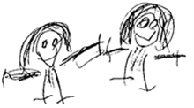
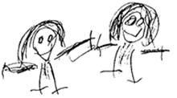

BRAMBLES CHILDCARE CIO

POLICY TITLE: | ADMISSIONS

POLICY REFERENCE: | BRAM01
Issue Number: | 02

2020-2021 | NAME | TITLE
Brambles Manager
Committee Member

2021-2022 | NAME | TITLE
Brambles Manager
Committee Member

2022-2023 | NAME | TITLE
Brambles Manager
Committee Member

Policy to be reviewed and signed annually (see above). Policy to be re-issued 3 yearly or when changes are required. Whichever occurs first.
Issue Date: | OCT 2020
Review Date: | OCT 2023

Statement of intent
It is our intention to make Brambles Childcare accessible to children and families from all sections of the local community.

Aim
We aim to ensure that all sections of our community in Bluntisham and Colne and surrounding areas have access to Brambles Childcare through open, fair and clearly communicated procedures.

Methods
In order to achieve this aim, we operate the following admissions policy.
We ensure that the existence of our setting is widely advertised in places accessible to all sections of the community.
We ensure that information about Brambles Childcare is widely known in all local communities, in written and spoken form and, where appropriate, in more than one language, through signing or an interpreter.
We give priority to children who live in the villages of Bluntisham and Colne and who attend St Helen’s School;

In Playgroup we keep two places vacant, if this is financially viable, to accommodate an emergency admission.
We describe Brambles Childcare and its practices in terms that make it clear that it welcomes both fathers and mothers, other relations and other carers, including childminders.
We monitor the gender and ethnic background of children joining the group to ensure that our intake is representative of social diversity.
We make our equal opportunities policy widely known.
We are flexible about attendance patterns to accommodate the needs of individual
children and families.

version History
Issue No | Significant changes from previous version | Author | Date
02 | Adopted on to new template | R Russell | 05/10/2020

